*Some Dare Call It Theocracy*

By Eric Holmberg and Stephen McDowell

Copyright © 2011 by Eric Holmberg and Stephen McDowell

First printing, December 2011

Providential Perspective Series — 10; (Perspective, Vol. 25:5)

All rights reserved. No part of this book may be reproduced in any manner whatsoever without written permission of the publisher, except in the case of brief quotations in articles and reviews.

Published by:

Providence Foundation Biblical Worldview University

PO Box 6759

Charlottesville, VA 22906

434-978-4535

Email: info@providencefoundation.com

www.providencefoundation.com

The Providence Foundation is a Christian educational organization whose purpose is to train and network leaders of education, business, and politics to transform their culture for Christ, and to teach all citizens how to disciple nations. The Biblical Worldview University (BWU) provides training for leaders of all ages and spheres of life in a curriculum of real-world topics, offered via distance learning (on DVD, CD, and/or print) and on-line in multiple languages. Live classes are also offered throughout the year in Charlottesville and other parts of the world.

The *Providential Perspective* is a regular publication of the Providence Foundation Biblical Worldview University and contains contemporary writings or excerpts from historical documents which focus on the relationship between God and history or Christianity and culture. It is sent to financial supporters of the Providence Foundation.

Printed in the United States of America

ISBN: 978-1-887456-40-1

Some Dare Call It Theocracy

**By Eric Holmberg and Stephen McDowell[1]**

# “The agenda of the religious right is a theocracy in the United States of America.”

**Frank Schaeffer on the *Rachel Maddow Show*, 9/20/11**

This ominous-sounding charge was made by the son of the late, great Francis Schaeffer as he discussed the Republican Party and political figures like Presidential candidate Michele Bachmann. The irony here is that Bachmann credits watching the elder Schaeffer’s *How Shall We Then Live*, the seminal analysis of western culture from a Christian-worldview perspective that was produced by Frank, as having sparked her initial interest in the nexus of faith and culture. But now, according to Schaeffer junior, by allowing Biblical truths to inform their world-and life-views, and then permitting those beliefs to guide their public policies, “theocrats” on the Right like Bachmann are seeking to impose a form of “Christian Sharia law” on the country. Their end-game: an America blessedly free of “immigration, black people, gays, and women having a right to choose,” where “whites are in the majority.”

The ravings of a backslider and traitor to both Jesus and his father’s legacy are easily dismissed. (Really, Frank? Herman Cain wants to get rid of black people? And Marco Rubio wants to stop immigration?) But the greater truth Christians need to understand is that the further our nation sinks into the abyss of humanism and statism, the more frequently the bogeyman of “theocracy” is going to be invoked whenever Christians dare to express their values in the public square of politics, government and law. As the Dr. Frankensteins to this imaginary theocratic monster—roaming our land in search of blacks and homosexuals to devour—we need to be up to speed on the presuppositions that drive the witch-hunt. The culture-war is about to get very ugly.

**Definitions:** First, what does the word “theocracy” mean? *Dictionary.com* is broadly representative in defining it as a form of “government in which God or a deity is recognized as the supreme civil ruler, the God's or deity’s laws being interpreted by the ecclesiastical authorities.” As Christians we understand that there is only one, true God. So a more precise definition would replace “God or a deity” with Yahweh or “the God of the Bible.”

# Historical Theocracies

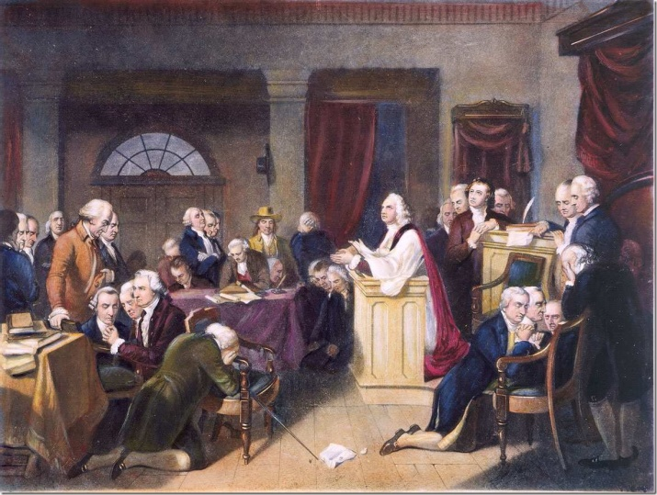The only true, God-ordained theocracy that has ever existed was Israel during the time of the Prophets and Judges, the *Urim* and *Thummim*,[2] and the manifest, *Shekinah* presence of God.[3] These Prophets and Judges were Israel’s “ecclesiastical authorities” who revealed the will of God infallibly when operating under the anointing of the Holy Spirit. To insure that His general will was clear to all the people, God Himself wrote down foundational moral and social principles upon which He designed the world to function. There was also the profound benefit of the supernatural presence of, and direct interventions by, Yahweh, the “lights and perfections” of the *Urim* and *Thummim,* and other miraculous guidance at this very unique time in human history. Israel’s citizens—the people God chose to bring redemption to the rest of the world by modeling the mysteries of the Gospel,[4] and through whom He brought the scriptures — were sheep being led by a very present Shepherd, who was manifest in part through literally *inspired* (from *in-Spirited*) leaders.

Sadly, because of Israel’s persistent disobedience, the glory of God eventually departed. But for a remnant of faithful prophets—who went largely unheeded and often persecuted—Israel was left a shell of its former self, simply going through the motions of being God’s people, but in reality no longer obeying His commands.

The First Prayer in Congress, September 1774.

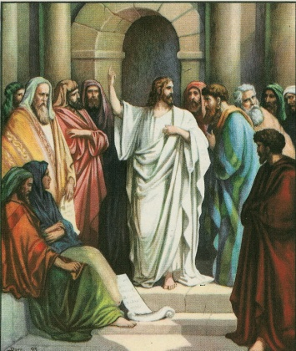This theocratic structure was reborn and transformed with the advent of Christ. At the moment of Jesus’ sacrificial death, the veil of the Temple was rent from top to bottom.[5] This symbolized the end of the Old Testament order and the birth of a “new and better covenant.”[6] Beginning with Pentecost, the Holy Spirit was poured out on all the redeemed—Jew and Gentile alike.[7] Thus the New Covenant/Church age began in earnest. Moses’ desire that “all the LORD’s people were prophets and that the LORD would put his Spirit on them!”[8] was wonderfully fulfilled. And Jesus’ last words before stepping out of our time-space continuum and into the Throne Room[9] of the higher, parallel reality we call heaven became—to borrow a useful analogy from Star Trek—the Christian’s *Prime Directive*:

All authority in heaven and on earth has been given to me. Go therefore and make disciples of all nations, baptizing them in the name of the Father and of the Son and of the Holy Spirit, teaching them to observe all that I have commanded you. And behold, I am with you always, to the end of the age.*[10]*

Jesus commissioned us to disciple nations by teaching all He commanded.

*Teaching nations to observe all the things that Christ has commanded*. That does sound rather theocratic doesn’t it? Is Schaeffer right about Bachmann and other faithful Christians, with the most notable Other being Christ Himself? Does Jesus want His servants to establish theocracies—as defined above—throughout the earth?

# That Was then; This Is Now

While every aspect of this new covenant is better than the old—even as the glory of the latter house surpasses the former[11]—to the less renewed mind[12] it doesn’t always seem that way. Who wouldn’t love to have seen the parting of the Red Sea or the glory cloud settle atop Mount Sinai; to watch, like Indiana Jones, the Shekinah fill the temple and settle over the mercy seat on the Ark of the Covenant? Most Christians today, though they have experienced the invisible, internal miracle of a changed, reborn heart, still secretly fantasize about seeing an incontrovertible miracle that would constitute the ultimate, inarguable “proof” of God’s existence and the truth of the Gospel. Surely that would be a better way, wouldn’t it?

Well, go ask Thomas (when he wasn’t exactly ten feet tall).[13]

The higher life to which we have now been called—walking by faith and living a self-governed life under the authority of God’s word and the leading of the Holy Spirit—is, from our Lord’s perspective, the better way. And this is not just the calling of some priestly or prophetic class of elites, but one all Christ-followers are called to enjoy and embrace.

There is an additional factor to keep in mind here. Perfect, God-breathed revelation through prophets ceased as the canon of scripture was completed around the time the Temple was destroyed.[14] God no longer spoke infallibly through a human agent. No longer were there any books waiting to be added to the Bible—no “new” New Testaments holding for a prophet’s pen.[15] This means that there is no longer any prophet or judge who can authoritatively reveal the word or the will of God. That is unless he or she is “rightly dividing the [already revealed] word of truth” contained in the scriptures.[16]

What does all of this mean with regard to the issue of theocracy? Just this: *Pentecost brought with it a profound democratization of culture*. With the advent of the New Covenant—and the accompanying emergence of God’s Kingdom—every man and every woman became a priest and a king before God. There is no longer an ecclesiastical elite that can consult the prophets or the *Urim* and *Thummim*. We can no longer follow a “cloud by day or a pillar of fire by night.”[17] Therefore, a theocratic state like the one established by God through Moses is neither possible nor, more importantly, something that God would now want us to reconstruct.

The eventual worldwide rule of Christ, as depicted in St. John’s Revelation, can only come through heartfelt, joyful, worldwide acclamation. There is not, nor could there ever be, another way.

We should also note that the New Testament epoch was and is a wonderfully inclusive one. At its institution, when the Holy Spirit began to draw from “every tribe, and tongue, and people, and nation,”[18] the church very rapidly became a multi-national, multi-ethnic affair. Apostolic leaders were forced to convene in Jerusalem around 50 A.D. to figure out what was expected from the small flood of Gentile converts entering the now-Christianized synagogues, in regard to the Jewish culture and laws from which the church sprang.[19] It “seemed good to the Holy Spirit and to [them]”[20] that many of the distinctives of the theocratic Jewish state should not be binding on the Gentiles. More slowly (and more painfully) they came to understand that many were no longer binding on Jews as well.

A massive sea-change was afoot with regard to what the Kingdom of God should look like in relation to this world. Clearly the Gospel had the power to change a person’s heart. Additionally, this inward change would inevitably result in the transformation of the person’s thinking, speech and outward behavior. The early Church also quickly learned that the transformation of a person can result in the conversion of an entire household.[21] And if a family can be transformed, why not a community? Not that everyone in the community will be converted,[22] but if enough are, because the “greater one” lives inside them,[23] might they also be able to impact the spiritual climate of that community to the extent that an approximate Christian righteousness and justice becomes the popular norm? And if this can happen to a community, why not a city, or a nation…or the entire world? Certainly there seemed to be verses in the Bible suggesting such a possibility.[24] Moreover, Jesus, Himself, hinted at it with the aforementioned Prime Directive.[25]

But what would a righteous city or a nation that had been taught “all the things” He commanded look like? What system of law and government would it employ? Clearly it would have to seek to follow and honor God. But how exactly would that work in the absence of divinely inspired judges and prophets?

# My Kingdom Is Not of this World.

So declared the Messiah to Pontius Pilate, the human judge in what became the most infamous trial in history.[26] Many today misinterpret Jesus’ words to mean that His is an other-worldly, heavenly kingdom that has little or no bearing on this (Pilate’s) world, which they view as ruled by Satan.[27] But such a perspective contradicts not only what Jesus and the Bible say about the devil’s post-crucifixion power,[28] but also the entire thrust of the Great Commission/Prime Directive: that Christians are to go into all the world and disciple nations. (This would be like a landlord telling his workers that he isn’t interested in a particular house, and then commanding them to go and clean the place up!) A careful reading of John 18:33-37, particularly in the context of Jesus’ other teachings and the rest of the Bible, yields a very different meaning: “My kingdom is not of this world. If my kingdom were of this world, my servants would have been fighting, that I might not be delivered over to the Jews. But my kingdom is not **from** the world”*[29]* (emphasis added).

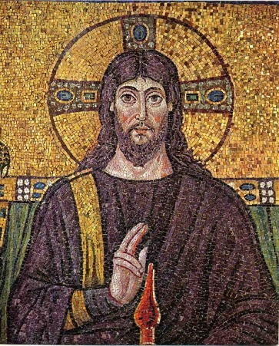By “servants who would have been fighting,” the Savior was referring to the same legions of angels He told Peter about in the garden of Gethsemane.[30] In essence, what Jesus was telling Pilate was, “Yes, I am a king. It was for this reason—to become a king and inaugurate My kingdom—that I came into the world. That is the truth. But this kingdom, my kingdom, is not of or *from* this world; it is not established nor does it operate in the manner of the Gentiles, like your kingdom.[31] Both your rule, Pilate, and that of Rome is hierarchical, a top-down governance that exists and is maintained by force. I could play this game if I wanted to and, by the way, completely annihilate you and anyone else who resisted me in the process.[32] But my kingdom comes and my will is done in an entirely different, even opposite way: through humility and servanthood rather than the use of force; by the power of love rather than the earthly threat of punishment and death. Mine is a bottom-up, “grassroots” movement, where hearts are changed and inclined to obey the commands I write on them.[33] Then, as my people love and serve others, the Gospel of my kingdom spreads until a tipping point is reached. Families, communities, and even entire nations are transformed, and people begin to willingly and joyfully delight in my ways and walk in my paths.[34]

Christ’s Kingdom is first birthed in the heart of man and then flows out to transform all of life.

# Discovering the City whose Builder and Maker Is God

For the early church the hope of converting a nation must have seemed like a pipe dream. Simply surviving amid the persecutions of the enormous, increasingly evil empire that was Rome was challenging enough. Remembering the words of Christ[35] and the admonitions of Paul,[36] Christians sought to be faithful to the LORD while serving their neighbors and living as model citizens of the empire *without compromising their primary (heavenly) citizenship*.[37] As much as possible they ruled themselves through their local churches, even setting up courts to settle grievances between Christians.[38] They might have glimpsed where all this was headed, however, when their pagan neighbors began appealing to these Christian courts to settle their complaints and lawsuits, knowing they were more likely to get true justice there than from the backlogged, corrupt Roman courts. Slowly but surely the “leaven” of Christianity spread throughout the Roman Empire[39]…until the impossible happened. With Emperor Constantine’s Edict of Milan in 313 A.D., the Christian faith became legal and rapidly rose to become the favored religion of the empire.[40] In just three centuries, Christianity went from being a tiny persecuted cult in the backwaters of Palestine to the dominant religious worldview of the time.

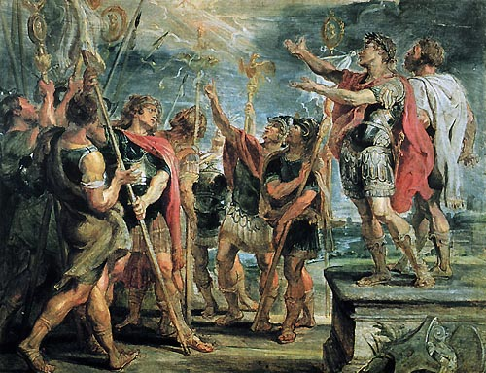Suddenly the relationship between church and state became a very real and pressing issue. As emperors, kings and other rulers, both then and later, made professions of faith and professed fealty to Christ, His word and His church, the hope of a Christianized nation grew from a wishful theory to a looming possibility.

Constantine’s conversion helped establish the Christian faith as primary in the Roman Empire.

It would be wonderful to say that what happened next was the result of slow, deliberate prayer, scripture study, and the combined wisdom of a great number of contemporary Ezras (priests) and Nehemiahs (governors), all working together to build a “shining city set on a hill.” But, sadly, even small, local human endeavors rarely develop in such an ordered and wise fashion. Expand such matters out to a nation or an empire (particularly one in decline) and one can only imagine the confusion, compromise, intrigues and back-room deals that must have occurred as a result of the seductions of money, power, nepotism, and the increasing number of wolves in sheep’s clothing in the church.

And so the histories of Rome during and after Constantine’s reign, Byzantium, the Medieval era (with the Crusades), European nations during the Age of Discovery and the Reformation are checkered with all manner of experiments in church-state relationships. Some skirted dangerously close to a caricature of the Old Testament theocratic model. Some were spectacular failures, particularly when the church usurped the state’s delegated powers and sought to wield the civil government’s God-ordained sanction for restraining evil: that is the “sword.”[41] During the various Inquisitions, for example, hundreds of thousands of men and women were investigated and many were tortured and killed as the medieval church usurped the powers of the state. In addition to direct executions, various religious wars were spawned resulting in many more deaths—over 30,000 in one day alone during the St. Bartholomew’s Day Massacre.

From the Ostrogothic Papacy to the Papal States, the divine right of kings, feudalism, the Magna Carta, parliaments, the rise and fall of various national churches, a host of ecclesiastical and social experiments were undertaken with varying results, both good and bad. But slowly, by fits and starts and much travail, a more faithful, Biblical model began to emerge, one that gradually began to recognize and respect the four divinely ordained spheres of individual, family, church and civil government, each with its limited authority, rights, and powers. All were to be under God, and checked to some degree by one another. But great care was to be taken that any one did not usurp the authority and duties of the others.[42]

With these ideas somewhat firmly in place—it was and remains a process—a band of “pilgrims”[43] from Europe sailed to the New World, quite intent on “rebooting” the European experiment in Christendom.[44] The famous words, recorded by William Bradford and agreed to by the settlers, known as the Mayflower Compact, summed up their intentions:

Having undertaken, for the Glory of God, and advancements of the Christian faith and honor of our King and Country, a voyage to plant the first colony in the Northern parts of Virginia… solemnly and mutually, in the presence of God, and one another, covenant and combine ourselves together into a civil body politic; for our better ordering, and preservation and furtherance of the ends aforesaid; and by virtue hereof to enact, constitute, and frame, such just and equal laws, ordinances, acts, constitutions, and offices, from time to time, as shall be thought most meet and convenient for the general good of the colony; unto which we promise all due submission and obedience.[45]

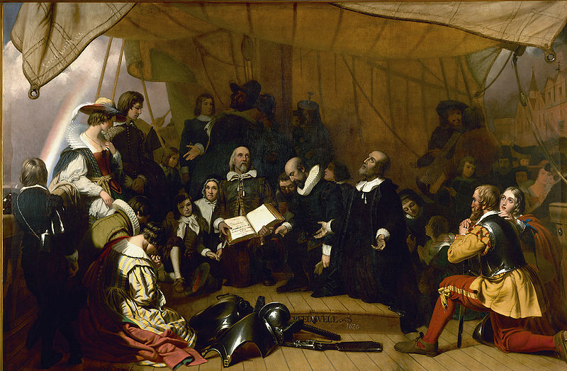If “theocracy” can be defined less colloquially and more literally as “the rule of God,” then it is hard to miss the theocratic elements in the preamble: “undertaken for the Glory of God…advancements of the Christian faith,” and “in the presence of God.” But note how equally conspicuous is the absence of any mention of a divinely appointed ruler or priestly oligarchy. In its place is the spirit of democracy: “one another…combine ourselves together into a civil body politic…the general good of the colony…we promise”—as well as an emphasis on the rule of law: “enact, constitute, and frame, such just and equal laws, ordinances, acts, constitutions, and offices.” Here, in a nutshell, is the essence of the American experiment in liberty, a uniquely Christian liberty: a democratic republic, self-governing, and with *Lex Rex*, only the “law as king,” that law being approved by the people—and with everything done to the glory of God.

Before sailing to the New World, the Pilgrims set aside a day of prayer and fasting, depicted here in a painting in the U.S. Capitol Rotunda. William Brewster is holding an open Bible upon which is written, “The New Testament of our Lord and Savior Jesus Christ.” On the upper left hand sail is written, “God with Us.”

This is borne out by the Fundamental Orders (Constitution) of Connecticut, published on January 14, 1639. It was the first of its kind to be penned in America and was later consulted as the United States Constitution was being composed, which is why Connecticut is known as “The Constitution State.” Here are a few highlights:

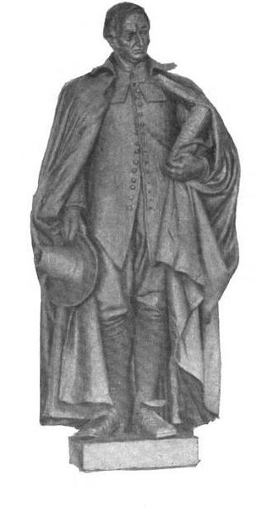 …well knowing when a people are gathered together the Word of God requires that to maintain the peace and union of such a people there should be an orderly and decent government established according to God, to order and dispose of the affairs of the people at all seasons as occasion shall require; do therefore associate and conjoin ourselves to be as one public State or Commonwealth; and do, for ourselves and our successors and such as shall be adjoined to us at any time hereafter, enter into Combination and Confederation together, to maintain and preserve the liberty and purity of the Gospel of our Lord Jesus which we now profess…which according to the truth of the said Gospel is now practiced amongst us; as also in our civil affairs to be guided and governed according to such laws, rules, orders, and decrees.

The Fundamental Orders of Connecticut was based upon a sermon preached by **Rev. Thomas Hooker** before the General Court on May 31, 1638.

It gave the governor and magistrates “power to administer justice according to the Laws here established, and for want thereof according to the rule of the word of God.” The required oath of office ended with the elected official saying, “I … will further the execution of Justice according to the rule of God’s word; so help me God, in the name of the Lord Jesus Christ.”[46]

One can almost hear the gnashing of teeth from Schaeffer and his ilk at such talk: Democracy, just and equal laws, and a civil body politic are all well and good. But we absolutely have to jettison any mention of God and His laws. It’s all just too… too theocratic. But that is precisely the point: It was not and is not. There was no state church that appointed and ruled over the civil magistrates and the people.[47] There was no oligarchy of priests, no “ecclesiocracy.” It was all completely organic and democratic. When the majority of people are voluntarily committed Christians, with a high regard for the teachings and the moral principles found in the Bible, it is inevitable that the democratic form of government they create will reflect and follow these same principles. Would Schaeffer have them jettison their deeply held beliefs and embrace something they didn’t believe in? And what then? And why? Simply to make him and Ms. Maddow happy? (More on this in a moment.)

# We Hold these Truths

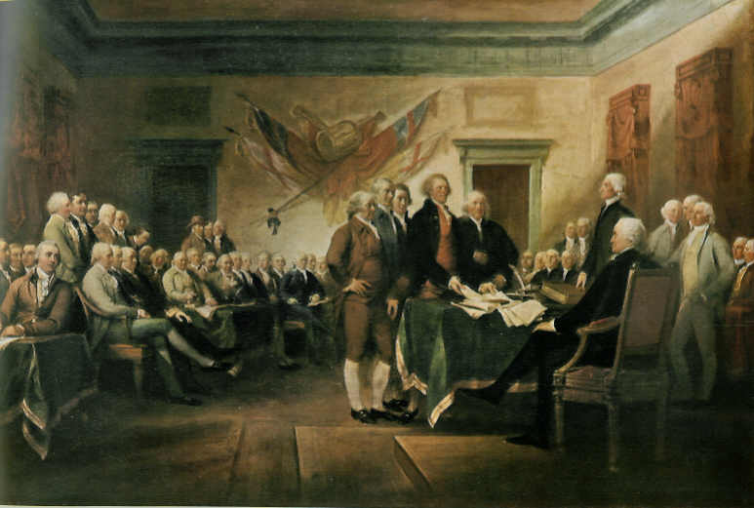There is probably no more recognized, cherished, and quoted statement from our founding documents—by people on both the right and left[48]—than the first sentence in the second paragraph of the Declaration of Independence:

“We hold these truths to be self-evident, that all men are created equal, that they are endowed by their Creator with certain unalienable Rights, that among these are Life, Liberty and the pursuit of Happiness.”

Truths were self-evident to our Founders because they believed in laws emanating from a Creator, Who gave a general revelation of them through nature and man’s conscience, and a specific revelation through the Holy Scriptures.

Right now, LGBTQ activists are invoking this great verse from our national canon to argue that homosexuals should enjoy the same right to marry, enjoy liberty, and pursue happiness as heterosexuals.[49] From people who want to legalize psychotropic drugs to the Occupy Wall Street crowd, thousands of other similar examples can be cited. *Everyone loves this “verse.”* But most forget where this “self-evident” notion came from. It did not just fall from the sky, fully formed and articulated. At the time of its writing it represented a radically new idea that would have been foreign—if not laughable, insane, or treasonous—to almost every other culture and nation throughout history. Was it *self-evident* to the pharaohs of Egypt, the Abbasid Caliphate, the Mongol Empire, or the court of Louise XIV of France that “*all* men are created equal”? The very thought would have provoked laughter, scorn…and even rage. Even today, is it self-evident to the Darwinian materialist, someone who believes only in a world of matter and its motion, devoid of any God or transcendent moral truth? Not if they’re honest and consistent with their foundational presuppositions. No, once again this great, founding principle, so cherished in our day, was at one time self-evident to only *one group of people*: Christians, or non-believers who had been thoroughly influenced by the biblical worldview through prolonged exposure to a vibrant Christian culture.

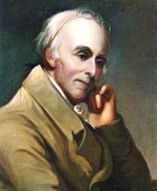And that is, to a man, who our founders were: Christians, with a smattering of Christian-thinking deists and Unitarians. These were men and women who thought christianly; whose writings and speeches cited the Bible and other explicitly Christian sources more than any other ancient tome by far. Almost to a man, they fit founder **Benjamin Rush’s** description of himself:

I have been alternately called an aristocrat and a democrat. I am now neither. I am a Christocrat. I believe all power … will always fail of producing order and happiness in the hands of man. He alone who created and redeemed man is qualified to govern him.[50]

It was these men who set out to create a nation unique in human history: where the government was of, by, and for the people; where rights came from God and not from man or the state; where the civil authorities’ powers were severely limited and their ongoing legitimacy was derived entirely from the consent of the governed. Even the very structure of our government—its three branches, each providing a system of check and balances on the others—was fashioned in the furnace of this vibrant Christian ethos, by men who understood original sin, human depravity, and the temptation of power to corrupt:

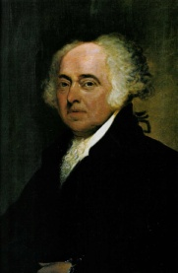To expect self-denial from men, when they have a majority in their favor, and consequently power to gratify themselves, is to disbelieve all history and universal experience; it is to disbelieve Revelation and the Word of God, which informs us, the heart is deceitful above all things, and desperately wicked…. There is no man so blind as not to see, that to talk of founding a government upon a supposition that nations and great bodies of men, left to themselves, will practice a course of self-denial, is either to babble like a new-born infant, or to deceive like an unprincipled impostor.*[51]* **John Adams,** Second President of the United States

# A Sober Warning

Our founders understood that while freedom was one of God’s greatest gifts to man, it was also among the most fragile, a candle that was ever susceptible to the angry winds of human iniquity. They recognized that our democratic republic could only work and endure if the people themselves were moral and self-governed. And they further understood that without religion—which was universally recognized as a belief system that found its taps roots in the Bible and the person of Jesus Christ—individual morality and self-government were nearly impossible. And in the absence of morality and self-government, either tyranny or destruction was inevitable.

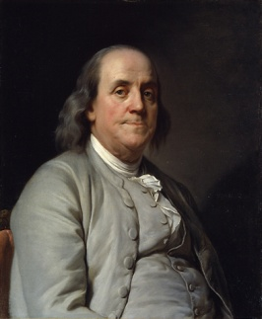This is why **Ben Franklin**, perhaps the least Christian of our Founding Fathers—but who nonetheless called the Constitutional Convention to prayer during a particularly difficult time—when asked by a lady what type of government the Convention had given our young nation remarked: *“A Republic, if you can keep it.”[52]*

On another occasion Franklin amplified his warning: “Only a virtuous people are capable of freedom. As nations become corrupt and vicious, they have more need of masters.”*[53]*

Other Founders were more explicit in connecting God with our form of government and the freedoms it allowed to flourish… as well as the perils of removing Him and Christianity from the national equation.

We have no government armed with power capable of contending with human passions unbridled by morality and religion . . . Our Constitution was made only for a moral and religious people. It is wholly inadequate to the government of any other.[54] **John Adams**

The only foundation for a useful education in a republic is to be laid in religion. Without this there can be no virtue, and without virtue there can be no liberty, and liberty is the object and life of all republican governments.*[55]* **Benjamin Rush**

The Christian religion, in its purity, is the basis, or rather the source of all genuine freedom in government. . . . and I am persuaded that no civil government of a republican form can exist and be durable in which the principles of that religion have not a controlling influence.*[56]* **Noah Webster**

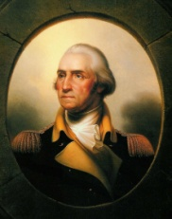

Religion and morality are the essential pillars of civil society.*[57]* **George Washington**

What happens to the national structure when these essential pillars are removed? Abraham Lincoln in a sense prophesied the answer: “America will never be destroyed from the outside. If we falter and lose our freedoms, it will be because we destroyed ourselves.”

Surveying our country in this hour, it is evident we are well into this process of self-destruction.

# Losing Our Freedoms/Losing Our Religion

Only someone who is ignorant or a willful liar with an agenda will deny the plain facts reviewed above: America was founded as a democratic, constitutional Republic by an overwhelmingly Christian-thinking populace.[58] Their hope and intent was that Christianity would remain the organic bedrock of our nation—its “controlling influence”—informing America’s laws and mores and helping regulate the affections and behavior of its citizenry. They were concerned about the intrusion of the state in religious affairs and as a result did not establish a national church, while further restricting the government from meddling in ecclesiastical affairs through the First Amendment. Their efforts, while far from perfect,[59] fashioned a nation—an experiment in Christian liberty—unparalleled in human history.

Sadly, that experiment has been going bad for generations. Today, we are witnessing a tragic tipping point, a chain reaction that threatens to destroy us from within precisely as Lincoln warned. There are a thousand and one things we could point to that have brought us to the brink of cultural suicide, but they can be summed up in the sober warning that **Moses** gave to the people who formed the world’s first experiment in biblical statehood:

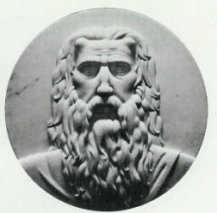“Take care lest you forget the Lord your God by not keeping his commandments and his rules and his statutes, which I command you today, lest, when you have eaten and are full and have built good houses and live in them, and when your herds and flocks multiply and your silver and gold is multiplied and all that you have is multiplied, then your heart be lifted up, and you forget the Lord your God... Beware lest you say in your heart, ‘My power and the might of my hand have gotten me this wealth.’ You shall remember the Lord your God, for it is he who gives you power to get wealth, that he may confirm his covenant that he swore to your fathers, as it is this day. And if you forget the Lord your God and go after other gods and serve them and worship them, I solemnly warn you today that you shall surely perish.”[60]

As America gradually grew into a “good” (relatively speaking), increasingly civilized, cultured, and prosperous country, we also gradually began to forget that there is truly no one good but God (Mark 10:18); that any virtue and excellence we possessed as a nation were grants of His grace to ameliorate the inherent depravity of man. We started to believe that it was our power and might that made us strong and prosperous. The necessity and power of the cross and the empty tomb were gradually overshadowed by a sentimentalism that nurtured the virus of Pelagianism.[61] Religion became increasingly bloodless and man-centered. More and more we forgot God, the fountain of living water, and hewed for ourselves broken cisterns that can hold no water.[62]

The language and symbols of our civic religion were progressively stripped of any traces of an omnipotent, immanent, awesome and *law-giving* God. Does anyone really think, for example, that John F. Kennedy or most of his national audience had the same God and religious sentiments in mind as John Winthrop did in 1630, when the new president invoked the puritan’s famous “city on a hill” metaphor in one of his first speeches?

I have been guided by the standard John Winthrop set before his shipmates on the flagship Arbella three hundred and thirty-one years ago, as they, too, faced the task of building a new government on a perilous frontier. “We must always consider,” he said, “that we shall be as a city upon a hill—the eyes of all people are upon us.” Today the eyes of all people are truly upon us—and our governments, in every branch, at every level, national, state and local, must be as a city upon a hill — constructed and inhabited by men aware of their great trust and their great responsibilities... For of those to whom much is given, much is required.[63]

Kennedy, or a speechwriter, even threw the words of Christ[64] into the mix. If anyone thinks all this was a sincere invocation of the worldview that characterized Winthrop’s time, try and imagine the newly elected president quoting from a latter portion of the same sermon.

Beloved, there is now set before us life and good, death and evil, in that we are commanded this day to love the Lord our God, and to love one another, to walk in His ways and to keep His Commandments and his Ordinance and His laws, and the articles of our Covenant with Him, that we may live and be multiplied, and that the Lord our God may bless us in the land whither we go to possess it. But if our hearts shall turn away, so that we will not obey, but shall be seduced, and worship other Gods… we shall surely perish out of the good Land… Therefore let us choose life, that we and our seed may live by obeying His voice and cleaving to Him, for He is our life and our prosperity.[65]

Can you hear the ACLU and their ilk, hissing like vampires at the dawn?

As the virus of Pelagianism continued to spread, our nation’s spiritual immune system progressively fell victim to a host of opportunistic “diseases”: Unitarianism,[66] religious syncretism,[67] Universalism,[68] dualism,[69] pantheism,[70] atheism and a host of other heresies.[71] The vibrant, orthodox Christian worldview that sparked our freedom fires was incrementally pushed further and further to the periphery of our national consciousness. And materialism,[72] humanism[73] and statism[74] rushed to fill the void. Three sexual revolutions (in the 20s, 60s and the third and final one we are in now[75]) further roiled the waters of our collective conscience and brought on a tsunami of destructive practices such as abortion, easy divorce, and “pomosexuality.”[76] We have finally come to the place where a Christian who dares to advocate a return to our founding principles is accused of being a theocratic, fundamentalist nut-job, hell-bent on imposing a Judeo-Christian form of Sharia law on everyone.

One might just as well condemn Samuel Adams, Patrick Henry and George Washington as white, Christian, Tea-Party-type extremists. And wait! They also had guns.

Booyah!

# The Issue Isn’t “No Religion,” but *Whose* Religion

We now end where we began. Are Christians like Michele Bachmann seeking to impose a theocracy on America? We trust what we have explored above exposes this fallacy for the propaganda that it is.

But there is one last point we need to make as we close. We could just as easily reposition the “scarlet T” by asking whether humanists like Frank Schaeffer or Barack Obama are actually the ones looking to impose their own form of theocracy on our nation. Why? Because ultimately their worldview—like all others—is based upon certain unprovable, faith-based presuppositions. And the source of this faith is necessarily their “god”—the “big idea” that informs their sense of meaning, purpose, destiny, and ethics.

Take, for example, those who are often seen as the least religious among us: atheists. The atheist, or philosophical naturalist, can claim that his is a reasonable faith—as can the Christian, by the way—but it remains a faith nonetheless *because there is simply no way to conclusively prove there is no God*. The locus of his alternative belief system—rationalism and empiricism rooted in the scientific method—abounds with *leaps of faith*, most notably that his mind—which he understands to be the product of blind, materialistic processes—can now “see,” can rise above the purposeless mechanisms that “created” him so that he can somehow reliably discern true order and purpose (the *sine qua non* of science) in the material world.

But the game gets interesting when this belief system is played out in the public square, in the guise of *neutrality*. The rules, with the ACLU enforcing them,[77] read this way: Christians are free to believe what they want in the privacy of their own heads and homes.[78] But when they enter the public square of government, law, education, commerce, or science, they must check their faith and values at the gate. That public square must remain religiously neutral, and Christians in particular (since they are so many and have had center-stage for so long) must keep their Bibles zipped and play nice. *But note the sleight of hand here*. What is the one religious worldview that is allowed in and given free reign and authority? Who is the one “god” that is placed on a pedestal? Why man, that’s who—and the religion of man: secular humanism/philosophical naturalism.

This is precisely what Barack Obama[79] was getting at when he said:

But what I also think is that we are under obligation in public life to translate our religious values into moral terms that all people can share, including those who are not believers. And that is how our democracy’s functioning, will continue to function. That’s what the founding fathers intended.[80]

As we have seen, our founding fathers intended no such thing; neither did they live, speak, and govern in this way.[81] More importantly, however, there is simply no way for Christians to “translate [their] religious values into moral terms” that atheists or humanists will accept. And why should they? Why should the Lord who created and redeemed us, who gave rise to America and sustained it, be shoved into a closet or reduced to a museum piece? And why should humanists be tapped to set the bar for public discourse? Why? *Because their belief system has become the de facto civic religion of America in the 21st century.* And it is precisely this religious worldview (*theos*) that wants to rule (*cratic*). It is a theocracy that will tolerate no competition… *all* *in the name of tolerance*.

In the end, it is people like Frank Schaeffer who are looking to impose— through sleight of hand rather than through an open, democratic process for which they don’t have the votes—their own brand of theocracy: secular Sharia.

The truth of the public square is that it is never a question of *no* values, but *whose* values; not of *no* absolutes, but *whose* absolutes; not of *no* god, but *whose* God? Someone’s ideas will prevail.

We prefer the free, democratic republic envisioned by candidates like Michele Bachmann; where religion—the Christian religion—and morality are once again the essential pillars of our civilization; where authority is the authority to serve, not decree; where faith is freely shared but never forced, and can only be freely accepted but never coerced. This is the essence of true Christian faith, the faith that built America, preserved America, and can restore America once more.[82] PP

# End Notes

1. To learn more about Eric’s work see, TheApologeticsGroup.com.
2. Exodus 28:30; 1 Samuel 14:41
3. Even though Israel was theocratic, it was a Biblically functioning theocracy (as contrasted with other religious theocracies in history and the religious theocracy some Muslims are seeking to establish today). While Israel did recognize God as the Supreme ruler, God did not rule directly, but through His Law, and through judges and representatives that the people chose and Moses confirmed (Deuteronomy 1:13-17; Exodus 18:12-26). Furthermore, He did not rule from the top-down, externally imposing His Law upon the people. God gave His Law to Israel and wanted the people to consent to live in accordance with it. The Biblical theocracy that God established with Israel contained many elements that we consider today to be part of free nations, including: election of representatives, rule of law, separation of powers, separation of jurisdictions, civilian military and police. (See Stephen McDowell and Mark Beliles, *Liberating the Nations*, Charlottesville: Providence Foundation, 1995, pp. 32-35). This is why Israel has been referred to as the Hebrew Republic.
4. There isn’t time here to fully develop this concept, but the rituals and many of the acts the Jews were commanded to perform—some of which seem strange and even offensive to modern minds (from sacrificing animals to stoning a person who gathers sticks on the Sabbath)—were symbols pointing towards redemption, and providing powerful insights into its mysteries. For a detailed development of this see Eric’s upcoming video *When the Bible Gets Ugly*. To be notified when it is complete, email us at *whenthebiblegetsugly@gmail.com*.
5. Matthew 27:51
6. Jeremiah 31:31; Luke 22:20; 2 Corinthians 3:6; Hebrews 7:22; among other verses. Forty years after Christ had established His church as a new “Mount Zion” and “heavenly Jerusalem” (see Hebrews 12:20), both Jerusalem and its temple were destroyed by the armies of Rome. The last vestige of the “old” covenant had been plowed under and buried. Furthermore, the rent veil in the temple tells us that the Holy Spirit (called the Shekinah or the Presence in the Old Testament) is no longer symbolically restricted to the location of the Holy of Holies. He has gone out into the entire world and is present “wherever two or more are gathered together in Christ’s Name” (Matthew 18:20).
7. Joel 2:28; Acts 2:17; Acts 10:45; among many other verses
8. Numbers 11:29
9. Particularly given our troubled times, Christians need to be ever mindful that this Throne Room is not far removed from our world, somewhere beyond the confines of our universe. It is the epicenter of a reality that surrounds us (Matthew 3:2); a taste of which is even within us (Luke 17:21). And that Throne Room—with a transfigured, glorified Man seated in the “captain’s chair” (Psalm 110)—doubles as the Control Room for Heaven *and* Earth (Matthew 28: 18-20; Revelation 1:5).
10. Matthew 28:18-20
11. Haggai 2:9
12. Romans 12:2
13. John 20:24-29
14. Only God knows for sure, but the majority report among current scholars is that Revelation was written after the destruction of the Temple (circa 90 to 92 A.D.). Nevertheless a growing number believe and argue, from textual as well as historical evidence, that the entire canon of the New Testament was completed by 70 A.D., that the “new” order was in place as the last vestige of the “old” order was being eradicated. While I am not an expert in the technical aspects of these matters, as an artist, writer and lover of symmetry, synchronicities, and symbols (and having come to appreciate God as a perfect lover and practitioner of all three), I‘ll bet anyone a dinner in the New Earth that ink was drying on the last scroll of the last book of the New Testament before or as Jerusalem was burning (Eric).
15. Christian theology has historically considered the New Testament canon—the compilation of the 27 books—complete since the end of the 4th century, with all of them having been written within sixty years (or less) of Jesus’ crucifixion. Throughout subsequent history the church has rejected all further writings, as well as claims to apostolic authority in writing them. Therefore, the *The Book of Mormon,* to take the most popular example, cannot be "another testament of Jesus Christ" nor can its author, Joseph Smith, or his successors be considered true apostles.
16. 2 Timothy 2:15
17. Exodus 13;21
18. Revelation 5:9
19. see Acts 15
20. Acts 15:28
21. Acts 16:31; Acts 10; 1 Corinthians 1:16
22. Matthew 13:24-30
23. 1 John 4:4
24. e.g., Isaiah 11:9
25. Matthew 28:18-20
26. John 18:36
27. Christians misinterpret this verse because their spiritual immune system has been compromised by the viruses of gnosticim and dualism. (See Eric’s article *Heaven is Important* … *But It’s Not the End of the World* at <https://www.theapologeticsgroup.com/export/Articles/HEAVEN%20IS%20IMPORTANT2.pdf>). Further, people like Frank Schaeffer and Barry Lynn, whether intentionally or not, misinterpret it to try and make Christians sit down and shut up…except when the occasional Christian’s views happen to coincide with theirs. So if they are into racial equality, they love it when a Martin Luther King arises and condemns racism using the words of scripture. But if they are “pro-choice,” any Christian who dares to defend life using the same Bible is condemned as a theocrat.
28. Genesis 3:15; John 12:31; Matthew 12:22-30; Colossians 2:15; 1 John 3:8; among many other verses
29. John 18:36
30. Matthew 26:53
31. Mark 10:42-45
32. Isaiah 37:36 records that a single angel obliterated 185,000 men in one night. Compare that to what Jesus told Peter in the Garden of Gethsemane: that He could deploy *more* than twelve legions (there were up to 6,000 men in a Roman legion) of angels if He wanted to defend himself. Taken literally, that is enough destructive power to wipe-out more than thirteen billion people, over forty times the total number of people on the planet at the time. Of course, we don’t think Jesus meant for this to be broken down mathematically in this way. He was simply saying that He could very easily impose His rule by force if he so chose. (He was also saying that the use of force is legitimate at certain times. See *Liberating*, pp. 86 ff)
33. Hebrews 10:16
34. Isaiah 2:3
35. Mark 12:17
36. Romans 13:1ff
37. As the reader probably knows, the early Christians’ primary loyalty to Jesus often got them into trouble. While their compassion, honesty, thrift, hard work, and willingness to serve their fellow man made them ideal citizens of Rome, they were not willing to acknowledge the vanity of some of the emperors who insisted they be honored as *kurios* (LORD). Their insistence that Jesus was the true LORD and that Caesar was but His delegated sub-regent got many of then jailed, tortured, and killed.
38. 1 Corinthians 6:1-7
39. Matthew 13:33
40. Some Christians today see Constantine’s legitimization of Christianity as a double-edged sword, and have come to emphasize its negative aspects: the flood of new communicants who were following trends rather than Christ, the political co-opting of the church that rendered it a creature and justifier of the imperial state, etc. No doubt some of this is true. But there were many blessings as well, not the least of which was that it ended the terrible persecutions Christians had suffered under Nero, Domitian, and Diocletian, among others emperors. For a well balanced view, see Peter J. Leithart’s *Defending Constantine: The Twilight of an Empire and the Dawn of Christendom*.
41. Romans 13:1-7, esp. vs. 4. The “sword” here is metaphorical and speaks of physical justice rendered against those violating civil laws. The “sword” could be a fine, a flogging, a hangman’s noose, etc. (see *Crime and Punishment* by McDowell for Biblical penalties for various crimes.)
42. This concept of jurisdictional authority and limited government was one of the civil teachings of Jesus (Matthew 22:17-21). Recognizing “to whom has God given authority to do what” has been important in the advance of liberty in history. The Bible teaches the purposes and responsibilities of individuals and the three divine institutions of family, church, and state. It also gives principles for the authority structure of these institutions. When one institution usurps authority from another, the result is loss of liberty. There are other spheres of government and influence that exist in society (for example, schools, businesses, associations), but these primarily flow from the family and individual as they perform their purposes. (See *Watchmen on the Walls*, pp. 25 ff, published by Providence Foundation.)
43. See Hebrews 11:13, 1 Peter 2:11
44. The term *Christendom* has unfortunately fallen into disuse and even become something of a pejorative, associated in many people’s minds with the excesses of the medieval church. Broadly, it simply refers to the *Corpus Christianum* or the “body” (total number) of Christians throughout the world. The suffix *dom* (condition or quality) also conveys the sense of rule (as in “kingdom”). Thus, more narrowly defined, *Christendom* is anywhere Christ rules in peoples’ hearts, and where there are enough Christians to organically influence and “Christianize” their culture. This is both a complicated and subjective phenomenon (e.g., what is the sufficient threshold of Christianization?) that will be explored a little later in this article.
45. Signed on November 11, 1620 by 41 of the ship's 101 passengers. *Colonial Origins of the American Constitution*, Donald S. Lutz, editor, Indianapolis: Liberty Fund, 1998, p. 31-32 (spelling has been modernized).
46. *Colonial Origins of the American Constitution*, pp. 211-215.
47. Connecticut, like 12 of the 13 colonies, would at the time of the American Revolution have some form of state establishment of religion. Eight colonies had a particular Christian denomination, and four others had Protestant Christianity in general, receive some sort of preference from the state. But this establishment was not like the National Churches that existed in Europe at this time. Some of the early settlers carried ideas of state religion with them when they started the colonies, but over time as they discovered fuller ideas of Biblical liberty, they disestablished state religion and put aside compulsion in regards to worship and thought. Their disestablishment of religion, though, did not mean they put aside God’s moral standards for personal and civil behavior. His Scriptures were maintained as the source of what was lawful and unlawful behavior. If this unlawful behavior affected the life, liberty, and property of others, the civil authorities could legitimately use the “sword” to execute God’s justice.
48. As if on cue, there has been some effort in the last few years to play down the word *Creator* as an unfortunate anachronism from a less enlightened time.
49. Legally speaking, they already do. It’s exactly the same as it is for “straights”: they can marry one (not two or more) person of legal age, who is not presently married, is doing so of their own free-will, and is of the opposite sex chromosomally. Everyone has exactly the same rights.
50. David Ramsey, An Eulogium Upon Benjamin Rush, M.D., 1813, p. 103. Benjamin Rush (1746 – 1813) physician, writer, educator, and humanitarian, was a Founding Father of the United States and a signatory of the Declaration of Independence.
51. John Adams, *The Works of John Adams*, Charles Francis Adams, editor (Boston: Little, Brown & Co., 1856), Vol. 6, *A Defense of the Constitutions of Government of the United States of America*, “**Chapter First. Marchamont Nedham. The Right Constitution of a Commonwealth Examined.”**
52. Notes of Dr. James McHenry, one of Maryland’s delegates to the Convention. McHenry’s notes were first published in *The American Historical Review*, vol. 11, 1906, with the anecdote on p. 618.
53. Benjamin Franklin, April 17, 1787, *The Writings of Benjamin Franklin*, 10 vols., Albert Henry Smyth, ed., New York: Macmillan Co., 1905-7, 9:569.
54. Message from John Adams to the Officers of the First Brigade of the Third Division of the Militia of Massachusetts, October 11, 1798, in *The Works of John Adams, Second President of the United States*, Boston: Little, Brown and Co., 1854, 9:228-229.
55. Rush, “Thoughts Upon the Mode of Education Proper in a Republic,” 1798.
56. Webster to James Madison, 16 October 1829,Madison Papers, Series 2, Library of Congress. Quoted in Defining Noah Webster, Mind and Morals in the Early Republic, by K. Alan Snyder, New York: University Press of America, 1990, p. 253.
57. “Farewell Address,” George Washington, Sept. 19, 1796
58. For more evidence of this truth see: Stephen McDowell, *America, a Christian Nation*; David Barton, *Original Intent*; Mark Beliles and Stephen McDowell, *America’s Providential History*.
59. Slavery and frequent ill treatment of Native Americans by whites fell far short of being Christ-like, to name the two most obvious examples of our early nation’s moral failure. It should be noted, however, that both issues cannot be broadly cited as pure examples of Christian American perfidy. There was a strong abolitionist stream, motivated by biblical principles, from the beginning of our country, one that, of course, eventually prevailed. Similarly, there are countless examples where Native Americans were treated with love, respect and equanimity. In fact, a primary reason for the founding of the colonies was to propagate the Gospel and “win… the Natives of Country, to the Knowledge and Obedience of the only true God and Savior of Mankind, and the Christian Faith” (Charter of Massachusetts Bay, 1629), with the desire they would then experience all of the “good life” that would follow. America, like individual Christians, was not and will never be perfect. But it is fair to say that there has never been a nation that realized the “shining city set on a hill” ideal more than America. Let us pray and labor to reverse our downward spiral and again begin ascending that mountain. (To learn more on the founders and slavery see Stephen McDowell, *Building Godly Nations*, “The Bible, Slavery, and America’s Founders,” Charlottesville: Providence Foundation, 2003.)
60. Deuteronomy 8:11-19. The founders agreed with Moses’ warning. The great statesmen of the Nineteenth Century, Daniel Webster said, “If we and our posterity shall be true to the Christian religion, if we and they shall live always in the fear of God and shall respect His Commandments, . . . we may have the highest hopes of the future fortunes of our country; . . . . But if we and our posterity neglect religious instruction and authority, violate the rules of eternal justice, trifle with the injunctions of morality, and recklessly destroy the political constitution which holds us together, no man can tell how sudden a catastrophe may overwhelm us that shall bury all our glory in profound obscurity.” (Benjamin F. Morris, *Christian Life and Character of the Civil Institutions of the United States*, Philadelphia: George W. Childs, 1864, p. 270.)
61. The belief that original sin did not ruin human nature and that men are therefore capable of goodness on their own, without grace from God. In other words, through their own good works men can save themselves.
62. Jeremiah 2:13
63. Address of President-Elect John F. Kennedy, delivered to a joint convention of the General Court of the Commonwealth of Massachusetts, January 9, 1961
64. Luke 12:48
65. *A Model of Christian Charity*, a tract written, and probably delivered, by John Winthrop on board the ship *Arbella* before the Massachusetts Bay colonists landed at Salem. Old South Leaflets, No. 207, pp. 20-21 (spelling has been modernized). 
66. The idea that God is a unity rather than a Trinity. Inevitably, this leads to denying the deity of Christ as well as losing the doctrine of “the one and the many,” a bulwark presupposition that helped give rise to the very notion of a democratic republic. Unitarianism also provides a fertile breeding ground for syncretism, the idea that all religions express some aspect of that unity and may be blended or embraced interchangeably. Not to beat a dead horse, but this also helps foment irrationalism, as syncretism forces people to deny the “law of non-contradiction” (a fundamental law of logic) and try to hold mutually contradictory ideas (e.g., simultaneously validating the Christian belief that Jesus is God, the Mormon belief that Jesus is one of many gods, and the Islamic belief that Jesus in not God).
67. Related to Unitarianism (see previous footnote), religious syncretism is the idea that all religions represent paths up the same mountain. Jesus is no longer “the way, the truth and the life” (John 14:6), He is only “a way”—and more and more not even a first choice.
68. If there is a heaven, everyone is going there. The common though more subtle way of saying essentially the same thing is to describe all people as “God’s children.” This is contrary to the Bible’s teaching that while all men are created in the image of God and have a God-given conscience, no one is truly a child of God until he or she has been born again.
69. Using Plato’s and Kant’s (and Eastern mysticism’s) two-tiered world, the philosophy that the universe of matter represents a fallen, lesser reality and that Truth and God exist only in a higher, spiritual plane—and never shall the twain meet.
70. From the Greek “pan” (all) and “theos” (God), the belief that everything is one and is or is a part of God.
71. As is always the case when apostasy sets in, we have even finally sunk to the level where full-blown paganism, witchcraft and other forms of the occult are also now in vogue.
72. By “materialism” we are not referring to being “materialistic,” having an inordinate drive to possess material things—although that certainly is a very real problem in America. Materialism, ideologically speaking, is the idea that nothing exists but the temporal world, i.e., matter and its motion. It denies the existence of God or the possibility of any received, transcendent revelation or truth. The universe is presently the closest permissible thing to a god, with secularism as its religion and science as its "priesthood."
73. The secular ideology that sees “man as the measure of all things” and looks to (supposedly) naked human reason as the arbiter of truth, ethics, and justice. It specifically rejects supernatural revelation and religious dogma as a basis of morality and decision-making.
74. The political philosophy that views the state and its regulatory powers as the source, protector and the dispenser of rights and the primary means by which to achieve economic and social goals.
75. See the next footnote
76. A new word that was actually coined in the LGBTQ world, with which every Christian needs to become familiar and use. Short for “post-modern sexuality,” pomosexuality is about shattering the binary divisions of good and evil, male and female, “straight” and “gay,” and championing a brave-new world where sexual tastes, gender identities, and familial and sex/love relationships are highly fluid and ever evolving. This is the third and final stage of the sexual revolution; final because it always immediately precedes the collapse of the society that enters it.
77. American Civil Liberties Union. These lawyers are our modern “ecclesiastical authorities,” interpreting laws originating from their god, which is man, with the goal of establishing their own theocratic rule.
78. Actually, our heads and homes are becoming less and less sacrosanct. For example, people who dare to believe that homosexuality is immoral, and is an obstacle to human and societal flourishing, are finding themselves being censured, fired, fined, denied licensure, and in other ways harassed and persecuted.
79. This is in no way to suggest that President Obama is an atheist; he clearly is not. (In fact, he claims to be a Christian.) But like a lot of professing believers he practices *de facto* atheism when it comes to the “naked public square.”
80. Comments at the fourth Democratic debate; the Citadel, Charleston, South Carolina, July 23, 2007.
81. If the reader needs any more clarity on this issue, consider the words of Declaration signer Benjamin Rush: “Christianity is the only true and perfect religion, and that in proportion as mankind adopt its principles and obey its precepts, they will be wise and happy.” (Benjamin Rush, *Essays, Literary, Moral and Philosophical,* Philadelphia: printed by Thomas and William Bradford, 1806, p. 93.) There is also this from Chief Justice of the Supreme Court John Marshall: “The American population is entirely Christian, & with us, Christianity & Religion are identified. It would be strange, indeed, if with such a people, our institutions did not presuppose Christianity, & did not often refer to it, & exhibit relations with it. (Daniel L. Dreisbach, *Religion and Politics in the Early Republic*, Lexington, Ken.: The University Press of Kentucky, 1996, p. 113.)
82. There are/were a number of candidates in the 2012 Republican presidential primary race who profess an apparently sincere faith in the Christ of scripture: Bachmann, Cain, Gingrich, Perry, Paul, and Santorum, in alphabetical order. Both Huntsman and Romney are Mormons, which, as we have noted elsewhere, the church has traditionally considered a non-Christian sect. From her words and actions it certainly appears that Bachmann understands the worldview outlined here, will not apologize or shrink from it, and will govern accordingly. Some of the other candidates seem to embrace much, if not all, of this worldview as well. The challenge in this hour is to train up an army of statesmen who, like Bachmann and our Founders, understand God’s mission for man on the earth.

    # Biblical Worldview University

    **Training Leaders to Transform Their Culture for Christ**

    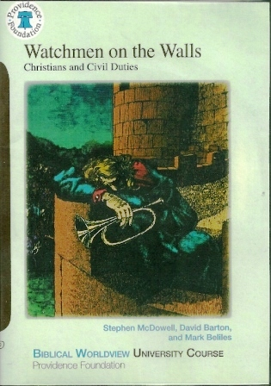 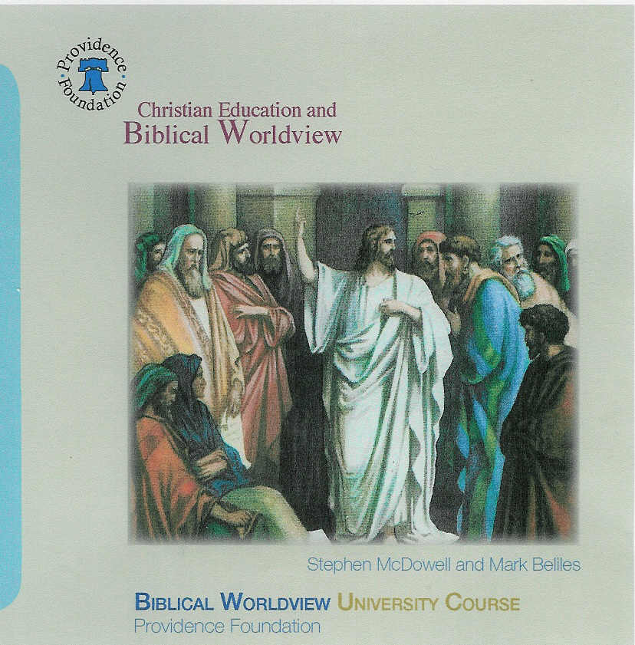 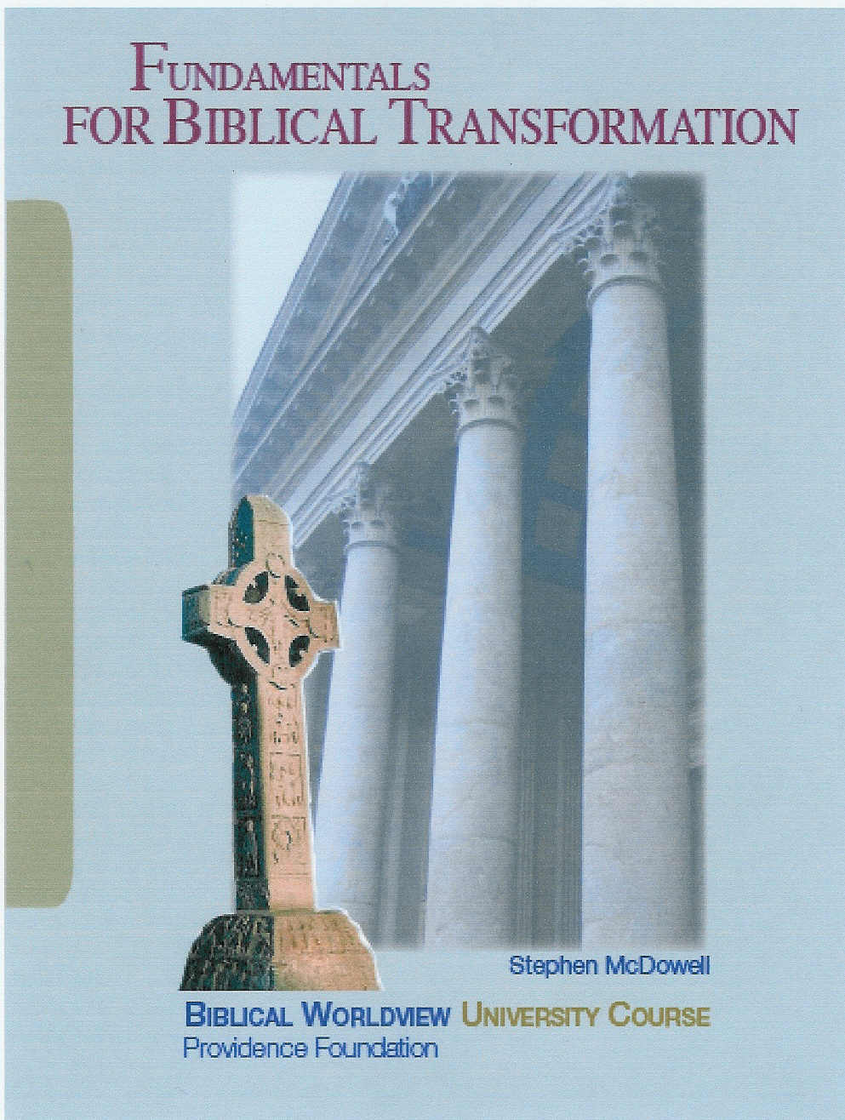

    Providence Foundation Resources

    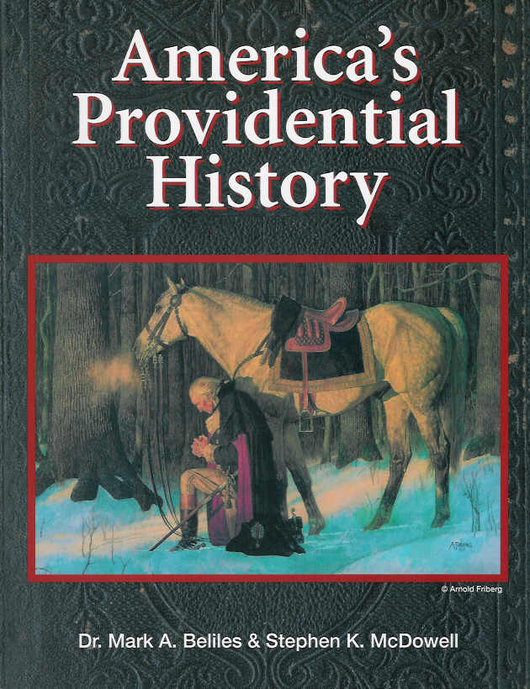 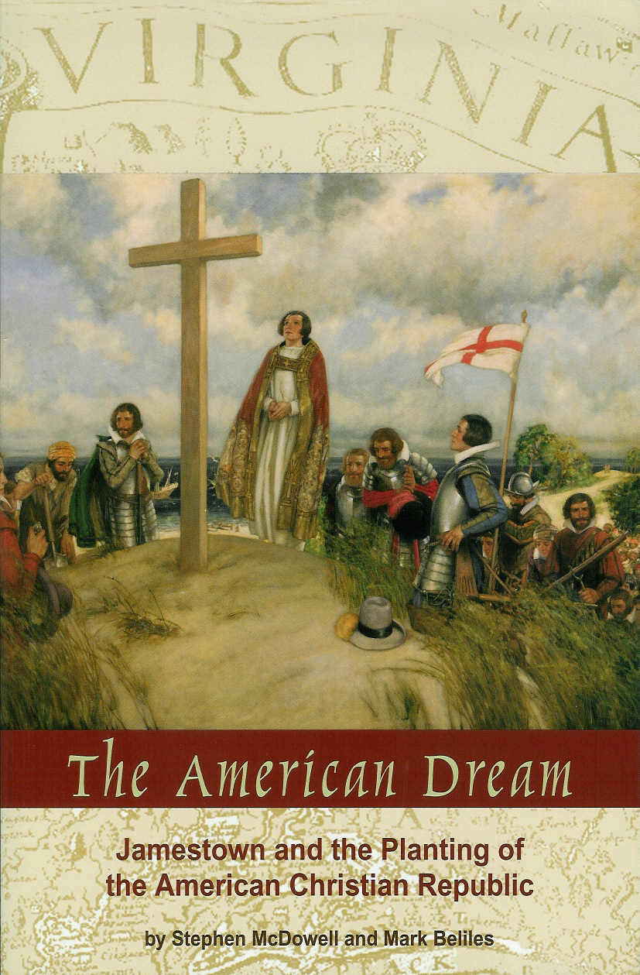 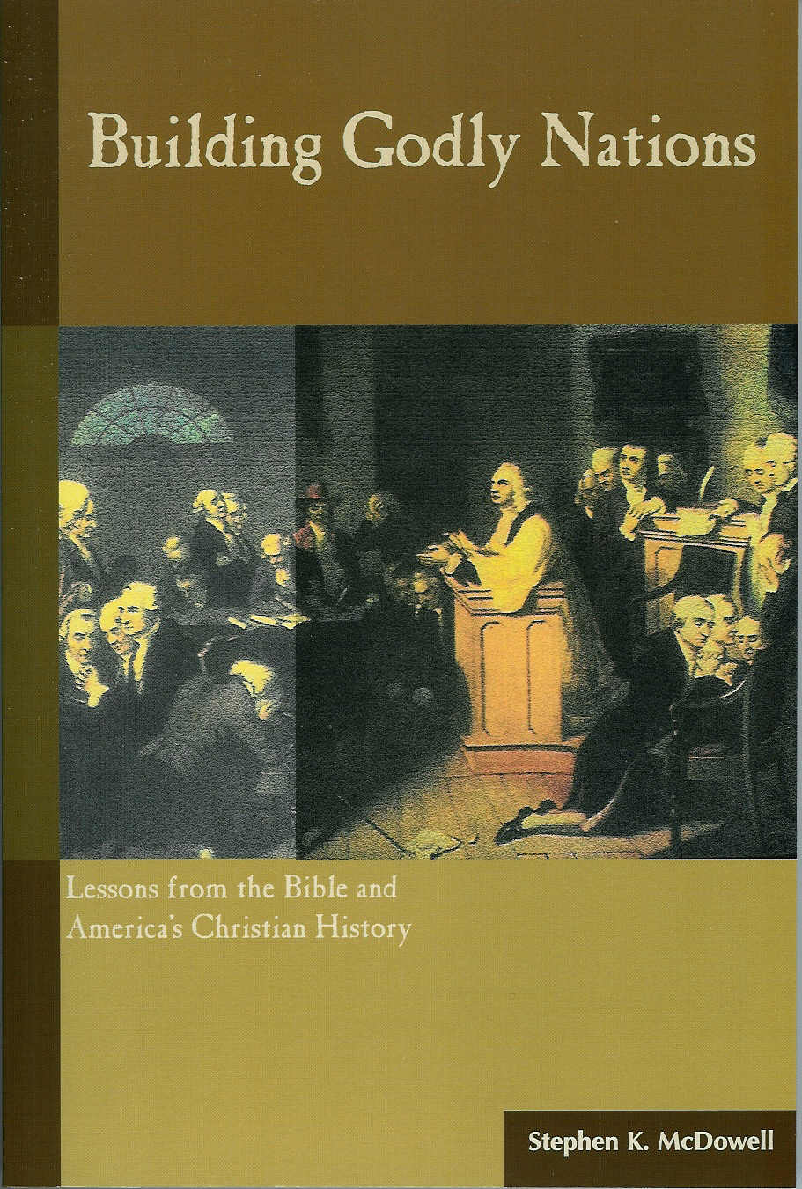

    **Order these courses, books, and other resources today:**

    www.providencefoundation.com

    Call 434-978-4535, or email us and request a catalog:

    [university@providencefoundation.com](mailto:university@providencefoundation.com)

    Become a Member and Receive Great Benefits

    Providence Foundation **Basic Member**: receive our newsletters, a 30% discount on all our books, videos, and materials, plus discounts to our seminars. **Premium Member**: receive Basic Member benefits plus a free book, $80 voucher toward one of our BWU Courses, personal coaching, and more.

    To join or receive more information email us or visit our website:

    providencefoundation.com